PROJECT DOCUMENTATION

[ Project Title ]
Student Name(s) | K.Keathana Vikashini(2520090236), V.Akshitha(2520080003)
Section / Branch | 7/CS IT, 7/AI DS
Academic Year | [ I Year, III Semester, 2025–26 ]
Course | Front End Development Frameworks and UI Engineering
Course Code | 25CS1201E
Faculty Guide | N.Shiva Krishna Assistant Professor
Date of Submission

Table of Contents
Chapter No. | Title | Page No.
 | Abstract | 3
1 | Introduction | 4
1.1 | Problem Statement | 4
1.2 | Objectives | 4
1.3 | Scope | 5
2 | Requirements | 6
2.1 | Functional & Non-Functional Requirements | 6
2.2 | Use Case Summary | 7
3 | System Design | 8
3.1 | System Architecture | 8
3.2 | Component Hierarchy | 8
3.3 | Route Map | 9
3.4 | UI Wireframes | 10
4 | Implementation | 12
4.1 | Technology Stack | 12
4.2 | Key Modules | 13
4.2.1 | Routing Module | 13
4.2.2 | Form Engineering | 14
4.2.3 | Accessibility | 15
4.2.4 | Performance Optimizations | 15
4.3 | Challenges and Solutions | 16
5 | Testing | 17
5.1 | Test Cases | 17
6 | Results and Discussion | 18
6.1 | Screenshots | 18
6.2 | Discussion | 19
7 | Conclusion and Future Work | 20
7.1 | Conclusion | 20
7.2 | Lessons Learned | 20
7.3 | Future Enhancements | 21
 | Appendix | 22
A | GitHub Repository | 22
B | Installation | 22
C | Individual Contribution | 23

Abstract
The Integrated Grievance Redressal System is a centralized digital platform developed to simplify the process of registering, tracking, and resolving public grievances. Citizens often face difficulties in reporting civic issues such as water leakage, electricity outages, potholes, and drainage problems due to the lack of transparency and communication between departments and the public. This project provides a user-friendly web application that enables citizens to submit complaints with multimedia evidence and track their status in real time.
The system incorporates automated complaint routing, priority-based classification, status tracking, and escalation mechanisms to improve efficiency and accountability. An administrative dashboard provides monitoring, reporting, and analytics features to help government officials identify trends and manage resources effectively. The application was developed using modern front-end technologies with a responsive and mobile-friendly design to ensure accessibility across devices. The project improves transparency, reduces complaint resolution time, and enhances citizen satisfaction through digital governance.

Keywords: React.js, Grievance Management, SPA, Routing, Dashboard, State Management, Responsive UI

Chapter 1: Introduction

Problem Statement
Citizens often struggle to report civic issues and track their resolution due to fragmented complaint systems and lack of transparency. Manual complaint handling leads to delays, poor communication, and inefficient grievance resolution. There is a need for a centralized digital platform that allows citizens to submit complaints, monitor progress, and receive updates. The Integrated Grievance Redressal System addresses this problem through a modern web-based solution.

1.2 Objectives
The objectives of this project are:
1. To develop a responsive grievance management platform.
2. To enable online complaint registration with evidence upload.
3. To automate complaint routing to relevant departments.
4. To provide real-time status tracking.
5. To implement an admin dashboard for monitoring and analytics.
6. To improve transparency and efficiency in grievance resolution.

1.3 Scope
The project focuses on the front-end implementation of a grievance management system. It supports complaint registration, complaint tracking, department routing, analytics dashboards, and status monitoring. The system is designed for public service sectors such as water supply, electricity, roads, and sanitation. Future versions can integrate real government databases and authentication services.

Chapter 2: Requirements

2.1 Functional & Non-Functional Requirements
The table below lists the key requirements of the system:

ID | Type | Requirement | Priority | Category
R-01 | Functional | Citizen registration and login | High | Authentication
R-02 | Functional | Submit grievances with multimedia evidence | High | Complaint Management
R-03 | Functional | Track grievance status | High | Tracking
R-04 | Functional | Automatic complaint routing | High | Routing
R-05 | Functional | Admin dashboard for monitoring | High | Administration
R-06 | Functional | Escalation for unresolved complaints | Medium | Reporting
R-07 | Functional | Generate reports and analytics | Medium | Complaint Management

Non-Functional Requirements:

ID | Type | Requirement | Priority | Category
R-08 | Non-Functional | Responsive design across devices | High | Performance
R-09 | Non-Functional | Fast page loading | High | Usability
R-10 | Non-Functional | User-friendly interface | High | Usability
R-11 | Non-Functional | Accessibility compliance | Medium | Security
R-12 | Non-Functional | Accessibility compliance | High | Reliability

2.2 Use Case Summary
Use Case 1: Submit Complaint
Actor: Citizen
Precondition: User is registered.
Flow:
- Login to system.
- Select complaint category.
- Upload details and evidence.
- Submit complaint.
Outcome: Complaint is successfully registered.

Use Case 2: Track Complaint
Actor: Citizen
Precondition: Complaint exists.
Flow:
- Login.
- View complaint history.
- Check current status.
Outcome: Real-time complaint status displayed.

Use Case 3: Manage Complaints
Actor: Admin
Precondition: Admin logged in.
Flow:
- View complaints dashboard.
- Assign departments.
- Monitor progress.
- Escalate unresolved complaints.
Outcome: Efficient grievance resolution.

Chapter 3: System Design

3.1 System Architecture
The application follows a client-side Single Page Application (SPA) architecture. All rendering is handled in the browser using React.js. Communication with any back-end occurs via REST API calls using the Fetch API or Axios.

Citizen → Complaint Submission → Routing Engine → Department → Status Update → Citizen Tracking
Admin Dashboard → Monitoring → Escalation → Reporting

Figure 3.1: System Architecture Diagram

3.2 Component Hierarchy

Component | Responsibility
App.jsx | Root application
Navbar.jsx | Navigation
Home.jsx | Landing page
ComplaintForm.jsx | Complaint registration
ComplaintTracker.jsx | Status tracking
AdminDashboard.jsx | Complaint monitoring
Reports.jsx | Analytics and reports
Footer.jsx | Footer section

3.3 Route Map

Path | Component | Access
/ | Home | Public
/login | Login | Public
/register | Register | Public
/complaint | Complaint Form | Protected (Login Required)
/track | Complaint Tracker | Protected (Login Required)
/admin | Admin Dashboard | Protected (Admin Only)
/reports | Reports | Protected (Admin Only)

3.4 UI Wireframes
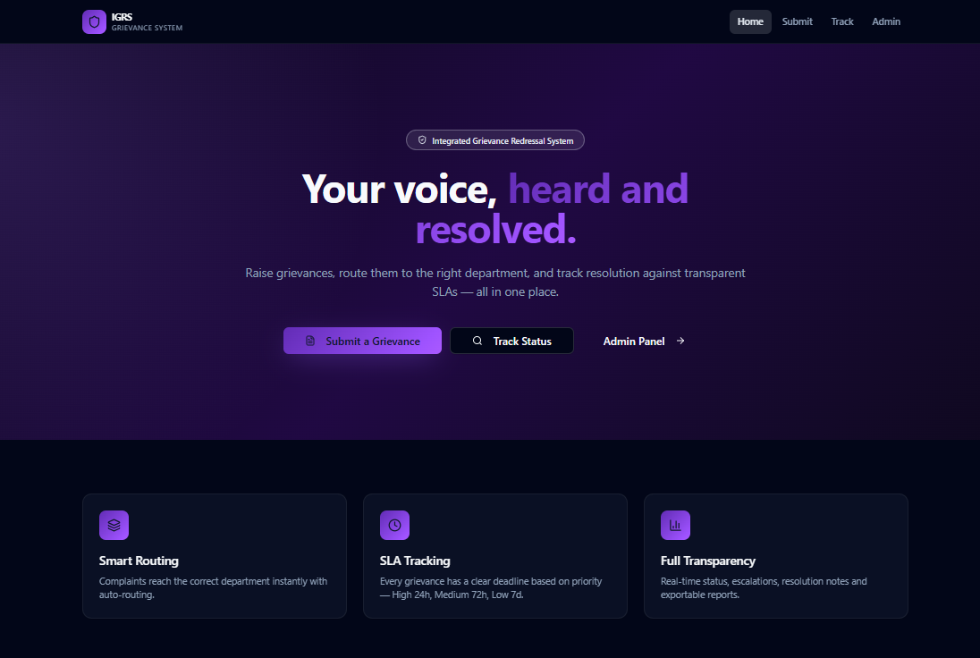

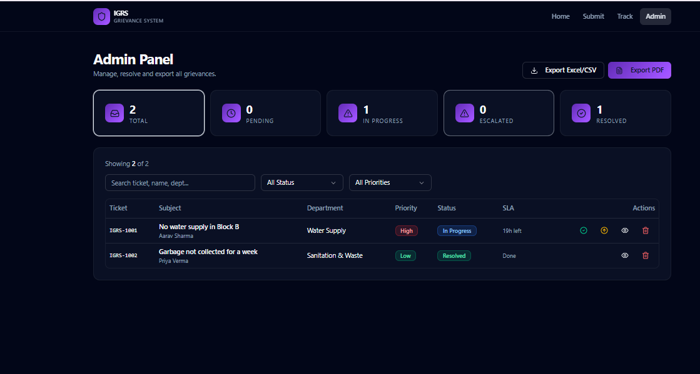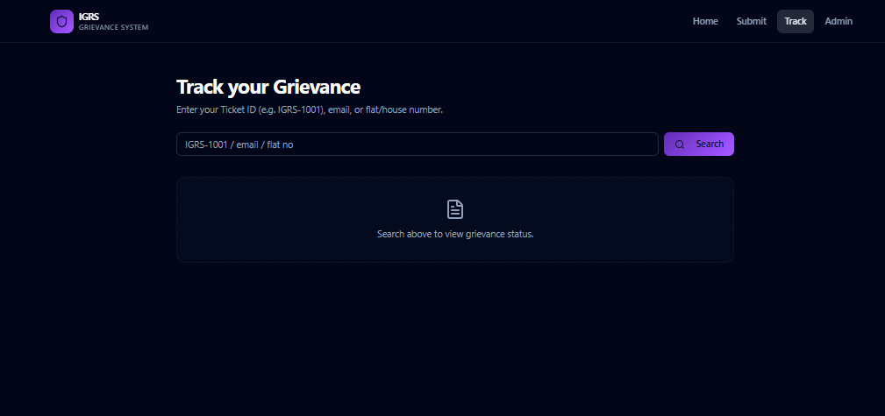

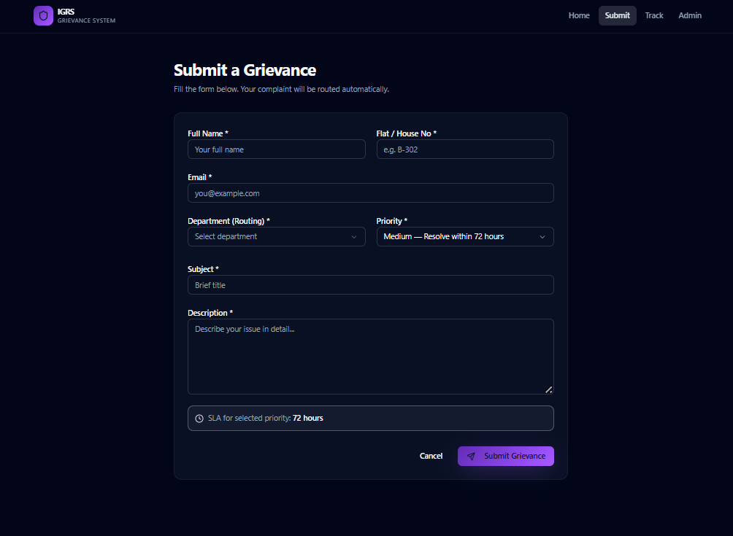

Chapter 4: Implementation

4.1 Technology Stack

Category | Technology | Purpose
Frontend | React.js | Develop a responsive and interactive user interface using reusable components.
Routing | React Router | Enable client-side navigation between pages without page reloads.
Styling | Tailwind CSS / Bootstrap | Design responsive, visually appealing, and mobile-friendly user interfaces.
State Management | Redux / Context API | Manage and share application data across multiple components efficiently.
Backend | Node.js | Handle server-side logic, complaint processing, and API services.
Database | MySQL | Store user information, complaints, status updates, and reports.
API Communication | Axios | Send and receive data between the frontend and backend through HTTP requests.
Testing | Postman | Test APIs and verify request-response functionality.
Version Control | Git & GitHub | Manage source code, track changes, and support team collaboration.

4.2 Key Modules

4.2.1 Routing Module
SPA routing was implemented using React Router. The application allows users to navigate between pages such as Home, Login, Register Complaint, Complaint Tracking, Admin Dashboard, and Reports without reloading the page. Protected routes are used for administrator pages to ensure secure access.
Routes Implemented:
Path | Component
/ | Home Page
/login | Login Page
/register | User Registration
/complaint | Complaint Submission
/track | Complaint Tracking
/admin | Admin Dashboard
/reports | Analytics & Reports
Purpose:
- Smooth navigation between pages.
- Improved user experience through SPA architecture.
- Secure access to administrative functions.

4.2.2 Form Engineering
The system uses controlled forms for user input. All complaint registration and login forms are validated before submission. Form fields are connected to React state, ensuring accurate data handling and real-time feedback.
Forms Implemented:
- User Registration Form
- Login Form
- Complaint Submission Form
- Complaint Tracking Search Form
Validation Features:
- Required field validation
- Email format validation
- Complaint description validation
- File upload validation
Purpose:
- Prevent invalid data submission.
- Improve data accuracy.
- Enhance user experience.

4.2.3 Accessibility
Accessibility features were incorporated to ensure the application can be used by a wide range of users.
Accessibility Measures:
- Semantic HTML elements
- Proper labels for all form fields
- Keyboard navigation support
- Responsive design for multiple devices
- Readable typography and color contrast
- Alternative text for images and icons
Purpose:
- Improve usability.
- Support users with accessibility needs.
- Ensure compliance with web accessibility guidelines.

4.2.4 Performance Optimizations
Several optimization techniques were applied to improve application performance and responsiveness.
Optimization Techniques:
- Component-based architecture for reusability.
- Efficient state management using React Hooks.
- Lazy loading of dashboard and reports pages.
- Optimized image and asset loading.
- Reduced unnecessary component re-renders.
- Responsive layouts using modern CSS techniques.
Benefits:
- Faster page loading.
- Improved user experience.
- Reduced resource consumption.
- Better scalability of the application.

4.3 Challenges and Solutions

Challenge | Solution Adopted
Managing multiple complaint categories | Created reusable form components and dropdown-based category selection
Maintaining complaint status updates | Implemented centralized state management for status tracking
Ensuring responsive design across devices | Used flexible layouts and media queries
Handling large numbers of complaints in dashboard | Implemented filtering and categorization features

Chapter 5: Testing

5.1 Test Cases

TC ID | Module | Test Description | Expected Result | Status
TC-01 | Login | Valid login | User logged in | Pass ✅
TC-02 | Complaint | Submit complaint | Complaint registered | Pass ✅
TC-03 | Tracking | Check status | Status displayed | Pass ✅
TC-04 | Dashboard | View complaints | Dashboard loads | Pass ✅
TC-05 | Reports | Generate analytics | Reports generated | Pass ✅
TC-06 | Routing | Department assignment | Correct routing | Pass ✅

Chapter 6: Results and Discussion

6.1 Screenshots

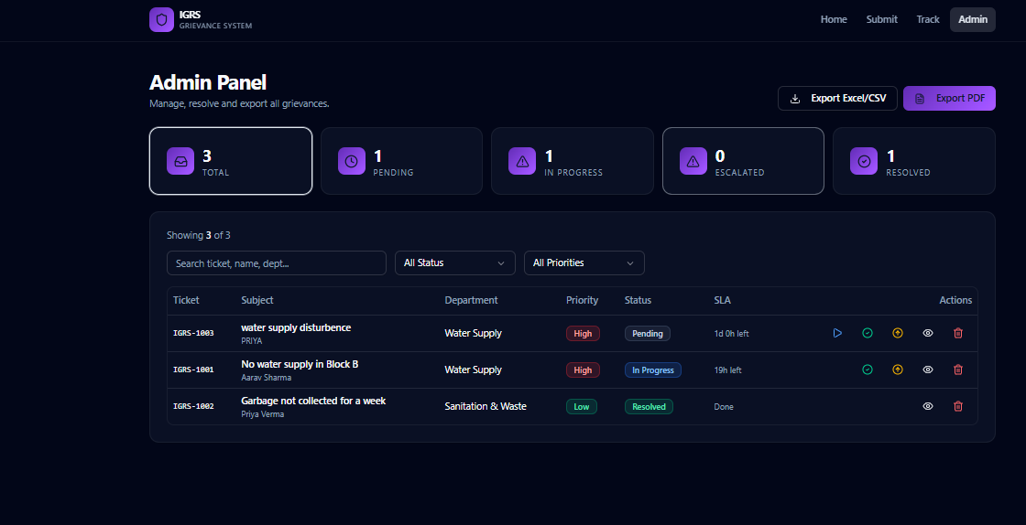

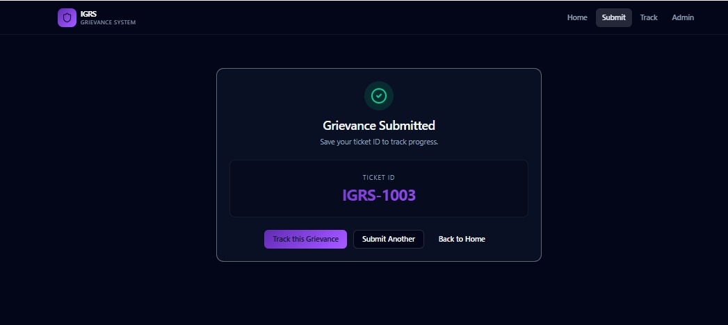

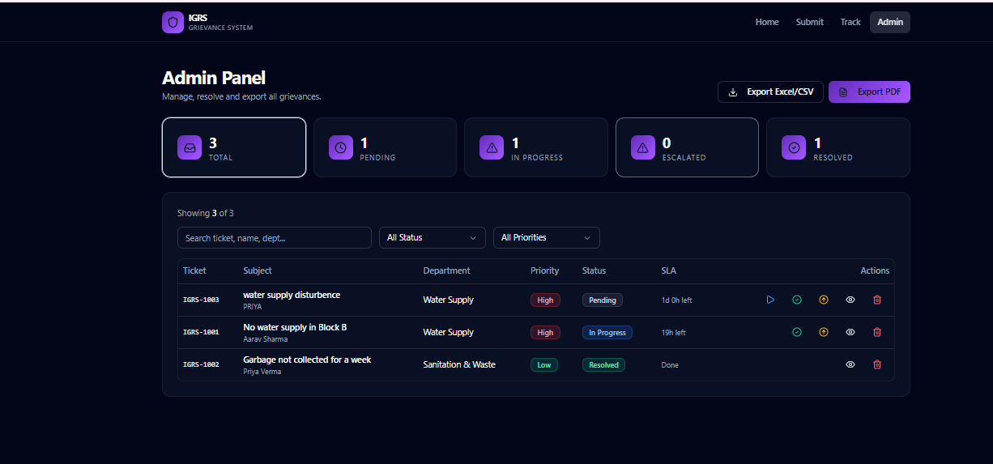

6.2 Discussion
The Integrated Grievance Redressal System was successfully developed as a responsive web application that enables citizens to submit, track, and manage grievances efficiently. The system provides a user-friendly interface for complaint registration, status tracking, and communication with concerned departments. The complaint management workflow functioned effectively, allowing administrators to assign complaints, monitor progress, and generate reports. The use of React.js and component-based development improved code reusability and maintainability.
The application performed well across desktop, tablet, and mobile devices due to its responsive design. Client-side routing enabled seamless navigation between pages without full page reloads, resulting in a smoother user experience. Form validation mechanisms reduced incorrect submissions and improved data quality. Performance was enhanced through efficient state management, optimized component rendering, and lazy loading of major dashboard modules, which reduced initial loading time and improved responsiveness.
Despite these advantages, the project has certain limitations. The current implementation focuses primarily on the front-end and uses simulated or limited backend functionality. Real-time notifications, advanced security mechanisms, and AI-based complaint classification were not fully implemented. Future enhancements can include integration with government databases, machine learning-based complaint categorization, SMS/email notifications, and GIS-based complaint mapping. These improvements would further increase the efficiency, scalability, and usability of the grievance redressal system.

Chapter 7: Conclusion and Future Work

7.1 Conclusion
The Integrated Grievance Redressal System successfully digitizes the complaint handling process. It enables transparent communication between citizens and departments while improving operational efficiency. The project meets its objectives of complaint registration, tracking, routing, and administrative monitoring.

7.2 Lessons Learned
1. Importance of responsive UI design.
2. Efficient state management using React.
3. API integration techniques.
4. Dashboard and analytics implementation.

7.3 Future Enhancements

1. AI-based complaint categorization.
2. SMS and Email notifications.
3. Mobile application development.
4. GIS-based complaint mapping.
5. Multi-language support.
6. Real-time chatbot assistance.

Appendix

A. GitHub Repository
Project Repository URL:
https://github.com/keathana2007/FEDF-PROJECT
Branch: main | Commit history includes descriptive commit messages per feature.

B. Installation
- Clone: git clone https://github.com/[ username ]/[ repo ].git
- Navigate: cd [ repo-name ]
- Install dependencies: npm install
- Start dev server: npm run dev
- Open in browser: http://localhost:5173

C. Individual Contribution (Group Projects)

Student Name | Roll Number | Modules / Contributions
K. Keathana Vikashini | 2520090236 | Citizen Interaction Module, Complaint Forms, Routing
V. Akshitha | 2520080003 | Admin Dashboard, Analytics, Testing, Documentation

